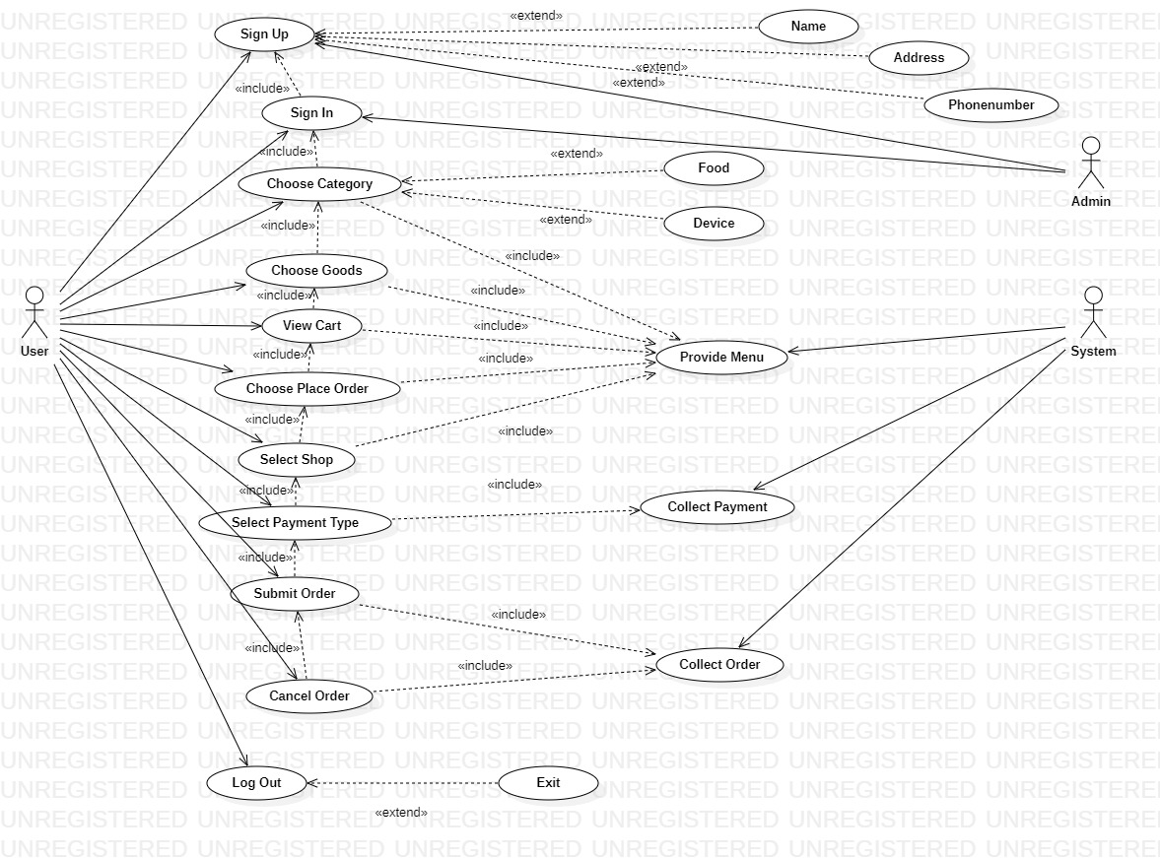
Sign Up
Actors | User, Admin
Description | An User send the user information to the Admin with the command that add this user into database
Data | User information
Stimulus | Interface that including username add register button
Response | Message that: register successful or fail (kind of error)
Comments | User provide user information and Admin must have permission to add user information.

Sign In
Actors | User, Admin
Description | An User send the user account to the Admin with the command that check this user from database
Data | User Account
Stimulus | Interface that including username add Sign In button
Response | Message that: SignIn successful or fail (kind of error)
Comments | User provide user information and Addmin have permission to check user account.

Choose Category
Actors | User, System
Description | An User send the Category to the provide menu and provide menu will reverse merchandise from system with the command that “choose category of goods”
Data | Category
Stimulus | Interface that including username add “choose category of goods” button
Response | Message that: Added successful or fail (kind of error)
Comments | User must have permission to choose category.

Choose Goods
Actors | User, System
Description | An User send the Goods to the provide menu and provide menu will reverse merchandise from system with the command that “choose goods”
Data | Goods
Stimulus | Interface that including username add “Add To Cart” button
Response | Message that: Added successful or fail (kind of error)
Comments | User must have permission to add to cart.

View cart
Actors | User, System
Description | An User send the list cart to the provide menu and provide menu will reverse merchandise from system with the command that “list cart”
Data | List cart
Stimulus | Interface that including username add “view cart” button
Response | Message that: Added successful or fail (kind of error)
Comments | User must have permission to view cart.

Choose place order
Actors | User, System
Description | An User send the order place to the provide menu and provide menu will reverse list of place from system with the command that “place”
Data | place
Stimulus | Interface that including username add “place options” button
Response | Message that: Added successful or fail (kind of error)
Comments | User must have permission to view place.

Select shop
Actors | User, System
Description | An User send the selected shop to provide menu and provide menu will reverse list of place from system with the command that “shops”
Data | shop
Stimulus | Interface that including username add “shops” button
Response | Message that: Added successful or fail (kind of error)
Comments | User must have permission to view shop.

Select Payment Type
Actors | User, System
Description | An User send the bill to the System with the command that “Buy”
Data | Bill
Stimulus | Interface that including username add “Buy” button
Response | Message that: Buy successful or fail (kind of error)
Comments | User must have permission to Buy.

Submit order
Actors | User, System
Description | An User send the order to collect order and collect order will reverse list of order from system with the command that “submit order”
Data | order
Stimulus | Interface that including username add “submit order” button
Response | Message that: Added successful or fail (kind of error)
Comments | User must have permission to submit order.

Cancel order
Actors | User, System
Description | An User send the order to collect order and collect order will reverse list of order from system with the command that “cancel order”
Data | order
Stimulus | Interface that including username add “cancel order” button
Response | Message that: Added successful or fail (kind of error)
Comments | User must have permission to cancel order.

